Lady Mary Wortley Montagu
and Smallpox Inoculation in 18th-Century England

by Erika Remillard-Hagen

Overview

This module is designed for high school biology students and will introduce the ideas of society, credibility, and gender roles in science. We will begin our discussion in 18th Century England, before Jenner’s Vaccination or the field of Immunology has been introduced. Students will follow the story of Lady Mary Wortley Montagu, author and ambassador’s wife, as she encourages an un-conventional approach to the fight against small pox. Students will have the opportunity to investigate issues relating to: a.) credibility in science; b.) cultural context of scientific thought and reasoning, and c.) parallels in our case study and ongoing/current developments in science/society.

Introduction

Everyone here today has been vaccinated against major disease causing illnesses. The CDC has prepared a schedule of vaccinations (Fig.1) required before entering the school system or leaving the country. Chances are that no one here has suffered from Diphtheria, Polio, Mumps, Hepatitis, Rubella- possibly even chickenpox, which is currently being encouraged if it hasn’t naturally occurred by the age of one year. These are issues of public health, to protect you and to protect others from infectious disease. What would be the result if we didn’t have them?

We take for granted the real magic of immunity because we live in a society where few ailments are fatal. The occasional flu virus is miserable to endure. But a flu vaccine is produced each year to protect those at risk or for those who simply wish to reduce the symptoms. Medicine is armed with the tools to prevent or at least lessen the threat of most life threatening communicable diseases.

Imagine a time before induced immunity. Imagine a time when diseases swept through cities and killed or disfigured most of its victims. A time when the cause of disease and its transmission were unknown and prevention was unheard of. How did societies cope with communicable illness before current scientific knowledge? And what was the process that allowed science to prevent or eradicate diseases that were once commonplace?

We will put ourselves in 18th century England and meet one woman who helped change the course of history by encouraging the acceptance of un-conventional science that worked.

Background-18th Century Europe

- Enlightenment- intelligence and reason, optimism, emphasis on science/methods. (Fig.1a, 1b)
- Rococo- freer, more feminine forms replaced baroque style. (fig.2) (Fig.3) (fig. 4)
- Death of Bach in 1750 marked end of Baroque/ beginning of Classical music.
- Women – became authors, poets, businesswomen, but still had a “place” as the more fragile of genders. (fig.5)
- Common to have slaves.
- Social/economic classes extremely divided-royalty through peasants
- Colonization- ethnocentrism
- Non-Christian cultures viewed as Barbaric
- Travel writing common-publicized above views
- Pre-cursors to Industrial Revolution-child labor, crime
- Population growth- doubled in London in 2nd half of century
- Disease, plague, typhus, smallpox

Smallpox- The Epidemic

- Most infectious disease in 18th century Europe
- Killed a fifth of those infected
- Rich and poor
- 1700-1800 Killed 195,865 people in London’s total population of 653,900
- More royal deaths than any other time period
  - Rulers of France, England, Spain, Sweden, Austria, Russia between 1700 and 1775
  - Louis XIV succeeded by grandson, lost 3 sons in 2 yrs.
  - Shifted line of succession, changing political history
  - Most children in London had smallpox before age 7
  - Those who lived through it were frequently disfigured or blind

Important here is to discuss theories of disease and contagion at that time. There was no knowledge of “bacteria” or “virus”. The nature of the cause of smallpox and other diseases was not understood. It is unknown how it was transmitted, its incubation period, or how it can be prevented or treated.

18th Century Science- theories on infectious Disease
- Theurgical beliefs- punishment/cleansing of sins-God
- Humoralists- balance of body fluids- blood, bile, and mucous.
  - Innate seed theory- inherent tendency of blood to ferment and expel waste through the skin.
- Atmosphere
  - “epidemic constitution of the air”- Girolamo Fracastoro, 1546, air as media for seeds.
  - Thomas Sydenham, 1624-1689, “noxious miasmas” raising from the earth
- Animalculae- Leeuwenhoek’s microscope, microorganisms. 1662-1723, breathed through nostrils, pores.
- Corpuscular theory-most popular-tiny particles enter and poison the body. Herman Boerhaave. 1668-1738

18th Century Treatment of Smallpox
- Theurgical- avoid sin, appease deity
- Humoralists- restoration of balance- bleeding, purging, sweating, enema
  - Rhazes heat treatment
  - Red light treatment-to reduce scarring
  - Diet restriction/fasting
    - Miasmists/atmosphere- cleaning environment, moving.
    - Contagionists/ Animalculists/Corpusculists- fled epidemic environment, isolation, and quarantine. (most common)

We will put ourselves in 18th century England and meet one woman who lived through the smallpox epidemic of 1714 and eventually helped change the course of history by encouraging the acceptance of un-conventional science that worked.

Lady Mary (fig.6)

- Born to nobility
- Great-grandfather founding member of the Royal Society
  - See notes on Royal Society
- Grew up in intellectual environment of upper class (males attended university)
- Love of literature of all sorts
  - See notes on Literature
- Bright, free spirited, did not settle into the female mold of the day.
- Outspoken and sharp, known for her beauty, wit, and poetry
- Eloped with Edward Wortley (fig.7), Parliament Member, at age 19
- Gave birth to a son
- Same year lost her brother to smallpox
- 2 yrs. later suffered from it herself, recovered, scarred and disfigured.1714
- Attending physicians were members of the Royal Society (presided by Isaac Newton, fig.8)
- see info on Royal Society
  - Had recently received correspondence from Dr. Emanuel Timoni, Italian Physician, who had practiced medicine in Turkey- he reported on practice of inoculation as a means to prevent death or disfigurement from the disease.
  - Was published in Transactions of the Royal Society in Oct. 1713 along with other “silly” stories on Giant’s bones, Comets, and Fortune Telling Dreams. ( Carrell, p.60)
  - Dismissed as ‘good for a pleasant little shiver of curiosity at the bizarre and backward practices of the east, but no more.’
  - Greek Physician, Dr. Jacob Pylarini, published on inoculation in 1715- read to Royal Society in 1716
  - Rumor had spread but it was dismissed as “wives-tale”
- Edward Wortley soon appointed as British Ambassador to Ottoman Empire. (Fig.9)
  - see info on Ottoman Empire
- Mary demanded to come along.
  - Was wearing mask in public to cover her severely pock marked face from London socialites.
  - Hired Charles Maitland, a Scottish Surgeon, to attend them throughout their stay in Turkey.
  - 1716 Wortley Montagu caravan left for Constantinople, by land.
  - Danger in exposing 3 yr. old son to smallpox and other ailments on the road.
  - Belgrade- spent 3 wks. W/ Islamic scholar - She embraced/respected culture.
  - Bathhouse in Sofia- Turkish women w/ unmarked skin struck Mary’s interest. (fig.10) The rumor is true? They have a weapon against smallpox.
  - Arrived in Constantinople March 1717

In April 1717, Mary wrote this letter home, to friend Sarah Chiswell:

Apropos of distempers, I am going to tell you a thing I am
sure will make you wish yourself here. The Small Pox, so fatal,
and so general amongst us, is here entirely harmless, by the
invention of engrafting, which is the term they give it. There is
a set of old women, who make it their business to perform the
operation, every autumn, in the month of September, when the
great heat is abated. People send to one another to know if any
of their family has a mind to have the small-pox; they make
parties for this purpose, and when they are met (commonly
fifteen or sixteen together) the old woman comes with a nut-
shell full of the matter of the best sort of small-pox, and asks
what vein you please to have opened. She immediately rips
open that you offer to her, with a large needle (which gives
you no more pain than a common scratch) and puts into the
vein as much matter as can lie upon the head of her needle,
and after that, binds up the little wound with a hollow bit of
shell, and in this manner opens four or five veins.

Every year thousands undergo this operation. There is no example
that anyone has died of it.

You may believe I am very well satisfied of the safety of the
Experiment since I intend to try it on my dear little son.

I am patriot enough to take the pains to bring this useful
invention into fashion in England, and I should not fail to write some of our doctors very particularly about it, if I knew any one of them that I thought had virtue enough to destroy such a considerable branch of their revenue, for the good of mankind. But that distemper is too beneficial to them, not to expose to all their resentment, the hardy sight that should undertake to put an end to it. Perhaps, if I live to return, I may, however, have courage to war with them. Upon this occasion, admire the heroism in the heart of your friend.

- During her stay Mary studied Turkish poetry, language, dance, and cookery. Immersed herself in the culture. (Fig.11)
  - See her letter home before leaving Turkey (Carrell, p. 84)

------------------------------------------------------------------------------------------------------------
Question: Place yourself in Lady Mary’s position. Would you inoculate your child? What would be your considerations in that decision?
------------------------------------------------------------------------------------------------------------

- Son inoculated in Turkey in 1718 before returning to England
  - Turkish woman engrafted his left arm with scratch of a needle,
Charles Maitland, Scot Surgeon, did right arm w/ scalpel.
(See comparison of Eastern vs. Western medical practice.)

Lady Mary’s Return
- Back home, built her case, made her plan.
- 1721, 3 yrs. after return, called on Maitland to inoculate her daughter.
  - Reluctant, he was a surgeon, not a doctor-bad for career
    - See notes on College of Physicians/ surgeons vs. physicians
    - Mary went to Royal family- Princess Caroline of Wales (fig.13)
    - Official witnesses appointed by gov’t. for procedure
  - Sir Hans Sloane (fig.14)(Pres. Of Royal Society/ member of College of Physicians/ king’s physician)-attended Mary during her own bout.
  - Dr. James Keith-who subsequently had Maitland inoculate his surviving children ( see info on James Keith)
- Mary was so worried about sabotage, inducing false experimental results, she stayed by her daughter’s side the entire time.
- Mary’s daughter, Keith’s children recovered and were visited by upper class friends
  - Parents of children, those who had lost family, friends to smallpox, began the practice.
  - By others, judged, booed, hissed at, called a witch, and a bad mother.

------------------------------------------------------------------------------------------------------------
Question: Having witnessed the inoculations and/or the recoveries of the children, would you now consider inoculating your child?
------------------------------------------------------------------------------------------------------------

The Royal Influence

- Princess Caroline requested to Sir Hans Sloane her children be inoculated. He refused to perform the procedure himself.
- George I, her father-in-law, gave permission for girl, not boys. (Fig.15)
- She coaxed him into setting up Newgate Prison experiment 1721
( Carrell, Chapter 6-Newgate, pages 264-277)
  - Medical, political, media witnesses
  - Maitland performed inoculations
  - 6 prisoners offered pardon in exchange for inoculation
  - 1 had already had smallpox-used as a control?
  - After recovery, 1 subject was sent to sleep in the same bed as a smallpox infected child- test of efficacy.

------------------------------------------------------------------------------------------------------------
Question: Having heard the results of the prison experiment, are you convinced that inoculation works? Are you more willing to inoculate yourself or a loved one?
------------------------------------------------------------------------------------------------------------

    - Following experiment, press frenzy. Two-parties formed while the epidemic continued.

Controversy
- Pro-Inoculation- Royal family, the Royal Society
  - Appeals to reason
  - Facts
  - Progress
  - Appeals to “the courtesy of gentlemen”
  - Expel seeds present in body-miasmists
    - Female/Cultural influence played down
      - Avoided speaking of folk medicine
      - Not Lady Mary but Edward Wortley who had his son inoculated
      - Not Caroline, but King George who initiated Newgate experiment.
------------------------------------------------------------------------------------------------------------
Question: Does it matter that Lady Mary was not trained in medicine or science? Does she have a case for inoculation based on her observations? Credibility?
------------------------------------------------------------------------------------------------------------

    - Anti-Inoculation-
  - Fear of inoculees spreading death
  - Religion-interfering with “God’s Intention”
  - Doubt of efficacy
  - Death from procedure
    - Female/Cultural influence accentuated
      - Turkey (land of harems)
      - Women at root- ‘seeds of smallpox transmitted in womb from impurities in mother’s blood’(Grundy, p.6)
      - “Posterity will scarcely be brought to believe that a method practiced only by a few ignorant women, amongst an illiterate and unthinking people should on a sudden, and upon a slender experience, so far obtain in one of the most learned and polite nations in the world as to be received into the royal palace.” W. Wagstaffe 1721. (Hopkins, p.47)

Developments
- Debate continued
- By 1722 at least 182 people inoculated in England, upper-class intellectuals.
- Existing doubts of efficacy by physicians.
- James Jurin, Secretary of the Royal Society, quantitative accounts on Mortality of Natural vs. Inoculated smallpox. Published between 1723 and 1727
  - 1st use of numbers to evaluate medical procedure
  - Years of data in correspondence network w/ physicians
    - 1/5 die of smallpox when contracted naturally
    - 1/50 die of smallpox when inoculated
------------------------------------------------------------------------------------------------------------
Question: Given these statistics, would you now choose to inoculate yourself or a loved one?
------------------------------------------------------------------------------------------------------------

  - study on value of bloodletting by Pierre Louis wasn’t conducted until 100 years later.
    - See background on bloodletting
  - Public trust in efficacy- inoculee deaths on the rise.
    - See notes on Eastern vs. Western medical practice
- 1726 Sarah Chiswell dies
    - Still fewer than 900 inoculated in England by 1730
    - Inoculation spread steadily, epidemic died down
    - 1731,1734,1736 epidemics
    - see notes on Western medical practice- unisolated inoculees
    - 1740s inoculation resurged, using material from recently inoculated donor.
    - 1752 severe epidemic
    - College of Physicians in London adopted inoculation in 1754
    - Suttonian Method in 1760s – “modified technique”
  - Actually the Turkish method Lady Mary had witnessed 50 yrs. earlier
    - No scalpels or aggressive medicine.
    - No preparation time- no bleeding/purging involved
    - Isolation-inoculated smallpox is contagious.
- 1764, Dr. Gatti- innate seed theory dies.
- 1768, William Heberden publishes on chicken pox as a distinct disease, clearing confusion of second attacks of small pox.
- By the end of the 18th century, widely accepted.

Questions for Review & Discussion

Question: What were the driving forces behind Lady Mary’s quest to get inoculation accepted in England?

Question: What were the issues in adopting the practice?

Question: What would be your considerations if you were told you could engraft yourself with cancer, for example, in the hopes of preventing it later in life? Does it depend on observation? The source of information? Their education? Gender? Years of statistical data? Desperation?

Question: Was it the backing of the Royal family that persuaded others to consider it? The 6-person prison experiment? The media? The persuasion of the Royal Society? Desperation? Science?

Question: What about the prison experiment? Ethics? Medical testing on prisoners? Comments? Concerns? Was this an acceptable (altruistic) way to come to a scientific conclusion about the reliability and efficacy of inoculation?

Question: What is “folk medicine”? What makes it less credible than other types of medicine? Would bleeding, or purging be considered folk medicine?

Question: Can you think of other discoveries or contributions to science made by women? Was credit given when due or was it revealed after the fact? Is it gender related or is it simply competition for recognition?

Question: Make a list of the discoveries or practices from Africa and the East that have since been adopted by Europeans? Why would other cultures be perceived as ‘barbaric’ and ‘unthinking’?

Question: Lady Mary was mentioned little throughout the controversy and even less until 1980 when smallpox was finally eradicated. Does she deserve recognition in the fight against smallpox? What is it she did exactly? Why is that important or necessary? What are other examples of similar actions in other discoveries or applications in science?

EPILOGUE

Along Came Jenner

- 1798, Jenner observes that exposure to cowpox provides immunity to smallpox. (Fig.16)
- Because cowpox has much milder symptoms than smallpox, it is adopted as a safer way to prevent smallpox infection.
- Jenner received a ton ‘o’ money from the British government for his contribution and further research.
- 1803 the Royal Jennerian Institute was founded
- By 1840, inoculation, using the smallpox virus itself, is banned.
1853 Vaccination made compulsory by Act of Parliament

Then to Now
See timeline (fig.17)

- Germ Theory in 1830’s 1840’s
- Koch and Pasteur-bacteriology 1870’s
- Viruses determined distinct from bacteria and protozoa 1890’s
- 1890, Emil von Behring, awarded first Nobel Prize in Physiology or Medicine, and Kitasato discovered antitoxins of diphtheria and tetanus- demonstrated that animals injected with small amounts of tetanus toxin became immune to the disease.
- Microscopic traces of variola 1887 by John Buist
- 1893 by Giuseppe Guarnieri
- 1904 by Councilman
- 1906 by E. Paschen
- 1920’s DPT, TB,
- 1939, U.K free of smallpox
- 1947 12 New Yorkers infected, 6 million vaccinated
- Smallpox virus seen for the first time in 1947 by electron microscope
- 1949 US free of smallpox
- 1960 China free of smallpox
- 1967 Global Eradication Program begins
- 1980 Smallpox Eradication

There was no clear understanding of immunity following infection, but something of that nature had been observed. Even before the knowledge of bacteria and viruses, it was known that certain diseases could not be contracted by the same person twice. Some sort of immunity had been obtained. It was observed by the historian Thucydides as early as 429 BC, that those who survived the smallpox plague in Athens did not become re-infected with the disease.

Inoculation was a means to expose the unexposed to a mild form of the disease, lessening the chances of contracting a more severe form of the virus naturally, and providing the survivor with protection from future infections. The Chinese, who had crushed the dried pustules of a smallpox victim and blew them into the nose of an unexposed person, had practiced it for over a thousand years. (fig.12) The practice was introduced to the Turks by way of China in the mid-17th century.
Lady Mary had observed “the magic” of immunization without knowing the internal mechanism. What she did know was that it would be difficult to convince Europeans of the treatment under the current system of medical knowledge without their having witnessed it themselves.

Excerpt from Speckled Monster: A Historical Tale of Battling Smallpox, by Jennifer Lee Carrell, Introduction, p.xiv:

“For all our current fears, we are inestimably lucky to live in a world in which the threat of smallpox has shifted from ordinary to extraordinary. Paradoxically, in the absence of smallpox as an everyday enemy, it is hard to realize just how lucky we are. Sheer numbers may help. By the time the disease was vanquished in 1977, it had become far and away the most voracious killer ever to stalk the human species. With a victim count in the hundreds of millions, smallpox has killed more people than the Black Death and all the bloody wars of the twentieth century put together.”

“The paradox of using smallpox to fight smallpox was not a product of methodical Western science. Its discovery and development lie hidden in the unrecorded history of the folk medicine of the Middle East, the Caucasus, and Africa. Many people around Lady Mary sneered not only at her lack of training, but at her willingness to pay serious attention to rumors coming from even more absurdly "ignorant" sources: Ottoman women and African slaves.”

Science in the first half of the 18th century

1700: Ole Romer invents the Meridian Telescope

1702: Guillaume Amontons invents a thermometer, which uses air as the expanding fluid, but improves on Galileo's earlier design by using air pressure rather than air volume

1703: Isaac Newton elected President of the Royal Society

1703: Although China had them centuries earlier, the first Seismograph of the West was invented by De la Hautefeuille

1704: Isaac Newton revives the dormant Royal Society, which had for many years been neglecting Natural Science. Publishes Optics.

1705: Francis Hauksbee proves that sound needs air to travel, by experiments with a clock inside a vacuum

1711: Coral, formerly believed to be plants, are proven to be animals by Luigi Marsigli

1712: Thomas Newcomen (born in Dartmouth, England, 24 Feb 1663) operates the first practical steam engine to use a piston and cylinder.

1713: Emanuel Timoni tells the (British) Royal Society that children in Turkey are inoculated with smallpox to prevent worse disease later in life.

1714: Dominique Ariel invents the fine-point syringe, still known by his name.

1717: Abraham Sharp calculates the value of "pi" to 72 decimal places

1718: Lady Mary Wortley Montagu’s son inoculated in Constantinople.

1721: America's first smallpox inoculation performed by Zabdiel Boylston, during the Boston Epidemic.

1721: Lady Mary Wortley Montagu has her daughter inoculated against smallpox, first inoculation in England.

1727: Physicist/Mathematician/Alchemist/Theologian Sir Isaac Newton dies in London

1730: Otto Muller born in Copenhagen, Denmark, 2 Mar. He becomes one of the first people since Leeuwenhoek to see bacteria, then goes on the classify them.

1757: Edward Jenner, then 8 years old, was inoculated against smallpox.

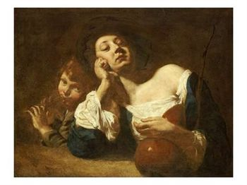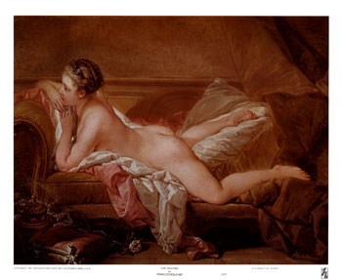
Fig. 2
Fig. 3

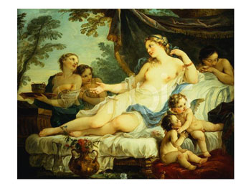

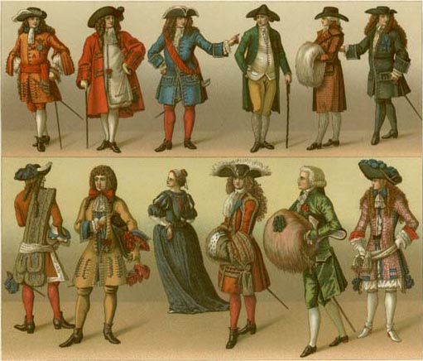
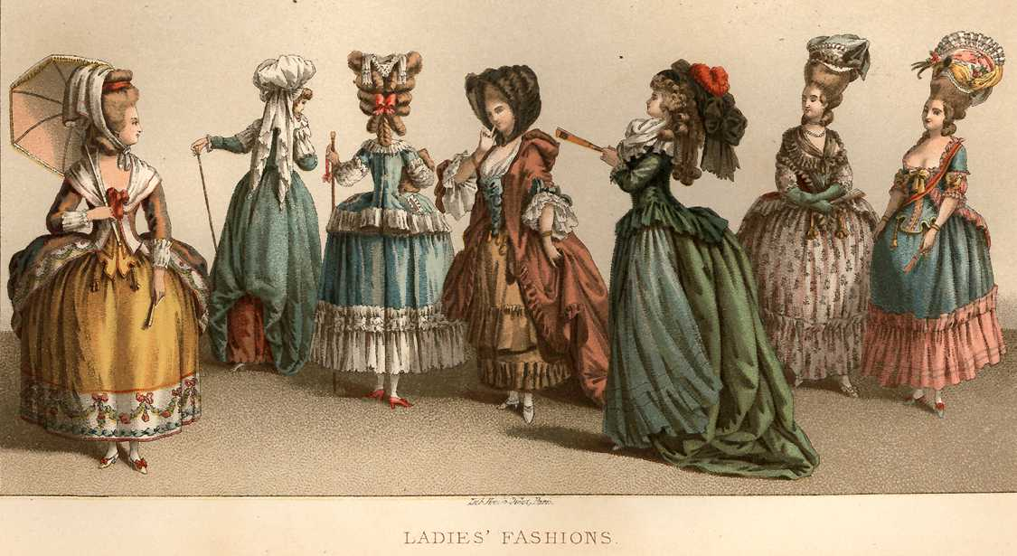
Fig. 1a
Fig. 1b

Fig. 5

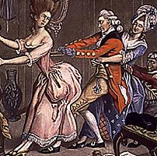

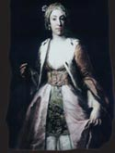 http://www.farketmezmagazine.com/photos/p20_1.jpg
Fig. 6

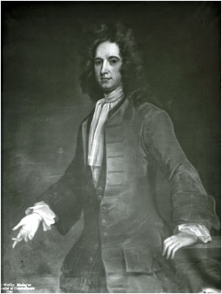
Fig. 7

http://www.gac.culture.gov.uk/search/Object.asp?object_key=26977

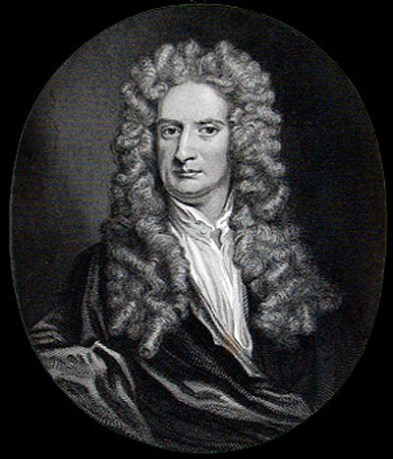
Fig. 8

http://www.virtualmuseum.ca/Exhibitions/Annodomini/THEME_15/FR/theme-fr-15-3-zoom.html

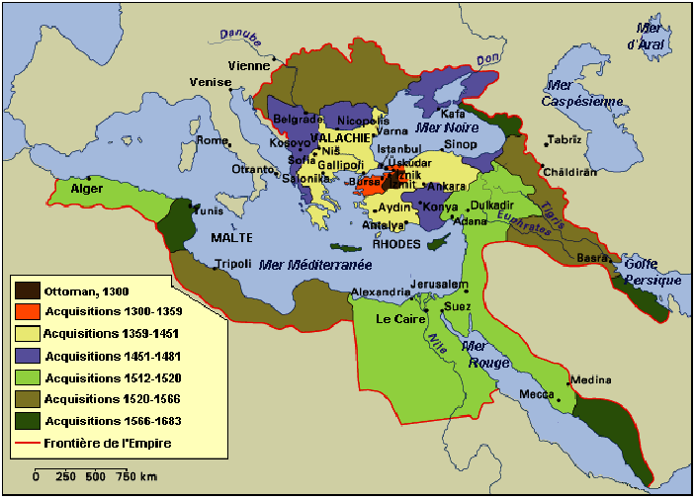
Fig. 9

www.stanford.edu/~ofidaner/turkiye.html

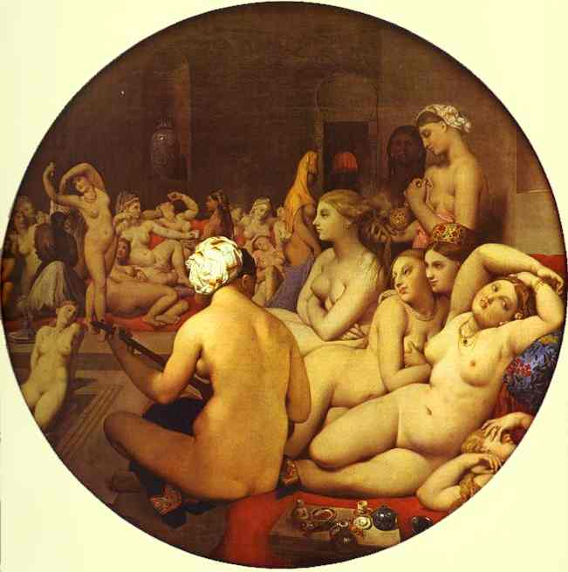
Fig. 10

www.abcgallery.com/I/ingres/ingres46.html

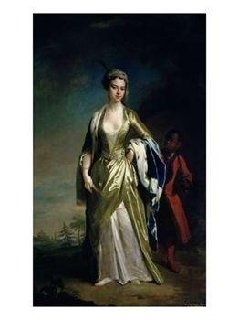
Fig. 11
www.jimandellen.org/finch/annmary.html

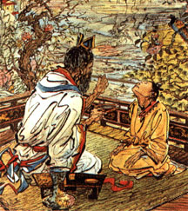
Fig. 12

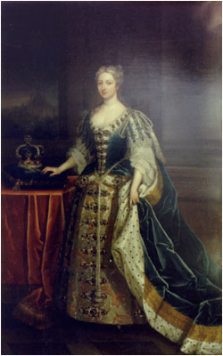
Fig. 13

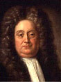
Fig. 14

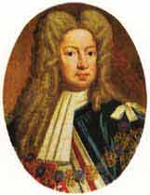
Fig. 15

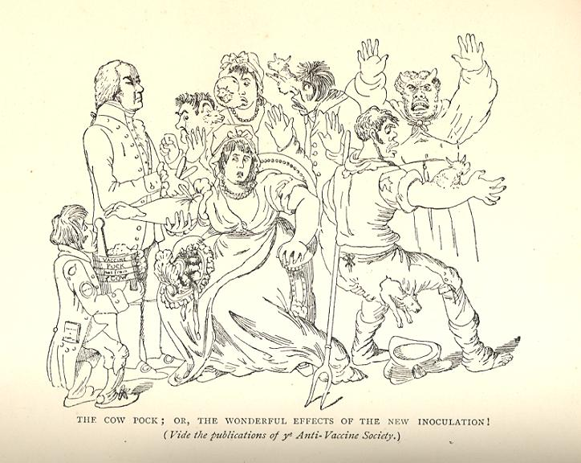
Fig. 16

www.blupete.com/Hist/.../Images?D=D

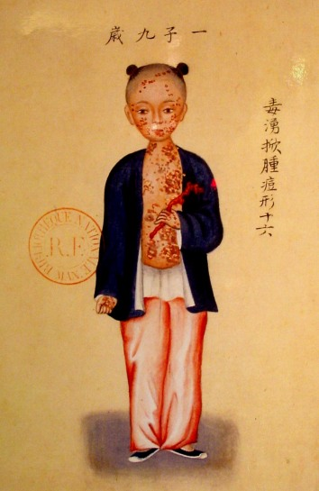

www.blupete.com/Hist/.../Images?D=D

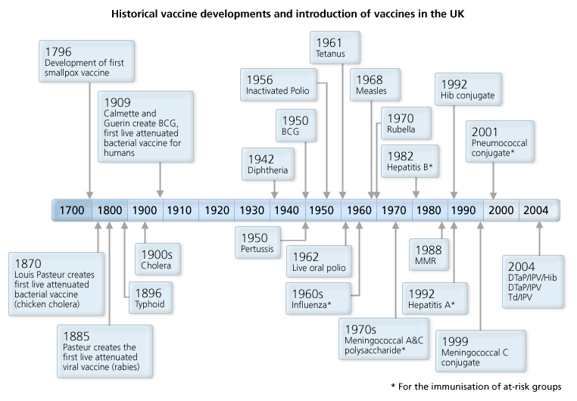

Fig. 17

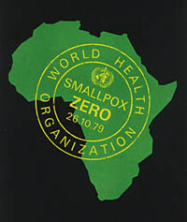
Fig. 18

