Particle Theory vs. Wave Theory

by
Michael Hamann

Learning Objectives:

The purpose of this module is to envelope the students in a hands-on environment where they can experience the evolution of our conceptual understanding of light. The students will learn aspects of scientific reasoning by replicating and interpreting Newton’s refraction experiment with a prism, and Young’s double slit experiment. These experiments will also aid in illustrating the evolution of light theory in a historical perspective.

Light as a particle:

Before the 19th century the popular belief among most scientists, notably Snel, Descartes, and Newton, was that light consisted of massless particles.

Laws of Geometric Optics:
Geometric propagation- Massless particles move in a straight line.
Reflection- Elastic collisions
Refraction- Snel’s Law: n₁ sin θ₁ ₌ n₂ sin θ₂
n=c/v, c=speed of light in a vacuum, v= speed of light in medium
Believed light moved faster in dense medium just like sound.

These laws did seem logical at the time because light always seemed to move in a straight line, reflection was predictable and seemed elastic, and Snel’s Law accurately predicted the refraction of light through a medium.

Newton:
Sir Isaac Newton was an advocate of the theory that light consisted of massless particles. He printed several works on the subject, most notably Opticks in 1704.

Opticks: Proposed white light consisted of many colors that could
be separated and then recombined with a prism through refraction.

Experiment 1: Newton’s refraction
(See experiment 1, and experiment 1 handout).

Newton had two main sources of evidence to prove his theory of light consisting of particles:
Sharp Shadow-
When you observe any shadow it appears to have
sharp edges. Sharp edges on shadows would be a
result of particle light. Waves would diffract around objects, resulting in fuzzy edges.

Light Travels in a Vacuum-
At this time it was thought impossible for a wave to travel in a vacuum. But everyone agreed that a particle would have no difficulty traveling in a vacuum.

Light as a wave:

In the 18th century, during the time that particle light theory was generally accepted, there was an alternate option presented by a minority of scientists. This alternative theory was that light consisted of waves, not particles. Most scientists did not believe this theory because of they observed shadow’s to have sharp edges and they thought it impossible for waves to travel in a vacuum.

Christiaan Huygens:

Christiaan Huygens (1629-1695) proposed that light was composed of waves that traveled through an aether. He was the first person to explain how wave theory can work with the laws of geometric optics. He stated that light waves propagate in straight lines at the speed of light. Traveling in straight lines as plane wave fronts would allow reflection to occur similar to the geometric optics, because the angle of incidence = angle of reflection (see picture 1). Huygens’ theory of refraction with light waves involves the light waves moving slower in a denser medium (see picture 2).
Objections to Huygens’ wave theory:
Huygens’ theory of light waves requires there to be an aether everywhere even in the vacuum of space. The presence of an aether would affect the motion of stellar bodies, which there is no evidence to support.
Objections to Newton’s particle theory:
Newton discovered an interesting phenomenon when observing light through the surface of two prisms with only a small pocket of air in between. He found that he could create concentric rings of color with gaps in between each circle. We call this phenomenon Newton’s rings. Newton struggled desperately to find a way for his theory of particle light to account for such a pattern. We now know this pattern to be an interference patter caused by refraction and diffraction. Newton explained refraction and diffraction by first stating that a medium he called the Aethereal Medium must exist. This medium supposedly transmitted vibrations faster then light, through which light is put into states of easy reflection and transmission resulting in refraction.

Discussion of which theory is correct?
Students have to make a decision on which theory is correct and give evidence to support there decision before discussing the correct theory.

Young’s Double Slit Experiment:
In 1803 a scientist named Thomas Young changed the particle versus wave debate forever. He conducted an experiment that proved that Huygens’ theory of light waves could account for the existence of Newton’s rings.

Experiment 2: Double Slit Experiment
(see experiment 2, and experiment 2 handout)

Constructive and destructive interference:
The resulting pattern of the double slit experiment and that of Newton’s

rings were both caused by constructive and destructive interference.

There is nothing in particle theory do explain this phenomenon, but wave

theory does explain this. Huygens’ wave theory allows for constructive

and destructive interference.

Interference:
Interference is caused by two waves that either cancel each other out (destructive), or combine into one wave (constructive). (see picture 3and 4). Waves can combine when they have the exact same frequency and wavelength, but will cancel out if they have the same frequency but have a ½ wavelength difference.
Constructive: y_{m} = (mλ L) / d
Destructive: y’_{m} = ((m+ ½)λ L) / d

Where m=0,1,2…, λ=wavelength, L=distance between slits and projection, d= distance between slits.

Conclusion:
How did our concepts of light evolve over this time?
After seeing Newton’s experiment we believed that his theory worked for separating colors from white light, but it didn’t explain the existence of Newton’s rings. After hearing Huygens’ theory we saw that it worked with the accepted laws of geometric optics, but with a few changes in refraction. At this point we had two working theories, neither was right or wrong. What evidence made you believe one over the other? Thomas Young’s double slit experiment proved that only the wave theory of light could solve the problem of the existence of interference patterns. But did his experiment end the particle versus wave debate? In 1849 French physicist Fizeau was finally able to prove that the speed of light was slower in water then in air. This disproved Newton’s use of Snel’s law, stating that light must move faster in a denser medium. Finally, using Maxwell’s equation, Michelson and Morley finally proved that light waves were EM waves and needed no medium to propagate in 1897.

Experiment #1
Newton’s Refraction

Purpose:
Purpose of this experiment is to teach students about the fundamental properties of light refraction and critical scientific reasoning skills, through the process of conducting and analyzing Newton’s experiment. Discussion of Newton’s results will also bring to light the historical significance of this experiment in the context of the particle vs. wave debate.

Supplies:
For this experiment a strong white light source, and a prism or diffraction grating

is required.

Process:
Set up a strong white light source to shine through a prism or diffraction grating to separate the light into the visible spectrum. Have students observe the difference in width and location between the spectrum colors.

Analysis:
What is the difference between the visible spectrums emitted from these two materials? After learning Newton’s interpretation of the results, is there enough evidence to support his claims? Why?

Application:
Newton believed that rays of light consisted of corpuscular particles. Newton’s theory is based upon the assumption that light speeds up as it enters a medium, and that the angle of refraction follows Snell’s Law. He describes the stronger red rays having less difficulty passing through the prism thus being refracted less. While weaker blue rays have a much more difficult time passing through the prism, thus being refracted more. After inspecting, students will hopefully have gained new skills in scientific reasoning, and also have realized Newton’s importance in a historical perspective.

Experiment 1
Handout
Newton’s Refraction

In this experiment you must observe the refraction of white light through a prism or diffraction grating resulting in the separation of light into the visible spectrum. This experiment was one of many found in Newton’s Opticks printed in 1704. Newton’s theory is based upon the assumption that light speeds up as it enters a medium, and that the angle of refraction follows Snell’s Law.

Snell’s Law: n₁ sin θ₁ ₌ n₂ sin θ₂
n=c/v, c=speed of light in a vacuum, v= speed of light in medium

He describes the stronger red rays having less difficulty passing through the prism, thus being refracted less. While weaker blue rays have a much more difficult time passing through the prism, thus being refracted more.

What is the evidence that supports Newton’s interpretation?

Is there enough evidence to support Newton’s interpretation? Why?

Experiment #2
Double Slit Experiment

Purpose:
Purpose of this experiment is to teach students about the fundamental properties of light diffraction and interference patters. Students will also use critical scientific reasoning skills, through the process of conducting and analyzing what they learned from Young’s experiment. Discussion of Young’s results will also bring to light the historical significance of this experiment in the context of the particle vs. wave debate.
Supplies:
Strong light source, material that does not allow light to pass through with

multiple slits and a dark room.

Process:
Set up a strong white light source to shine through the slits in the material to

project an interference pattern. Have students observe the difference in width and

location between the light and dark areas.

Analysis:
What is the significance of Young’s double slit experiment? Does this experiment provide enough evidence to prove the wave theory over the particle theory? What are some possible objections an advocate of the particle theory might bring up with this experiment?

Application:
Newton did not have a valid explanation for the existence of Newton’s rings if light consisted of particles. Young’s double slit experiment had immense historical implications on the particle versus wave debate because it proved that Huygens’ theory supported the existence of the rings while Newton’s theory did not. I hope students will use there scientific reasoning skills to see the historical significance of this experiment, and how this experiment is still effecting our lives today.

Experiment 2
Handout
Double Slit Experiment

In this experiment you must observe the projection of the light through the slits of the material and witness the resulting pattern. This experiment was conducted in 1803 by Thomas Young to see if wave theory accounts for the existence of Newton’s rings.

Describe the pattern you observed.

What could cause such a pattern?

What is the significance of this experiment in terms of the particle vs. wave debate?

What are some possible objections an advocate of the particle theory might bring up with this experiment?

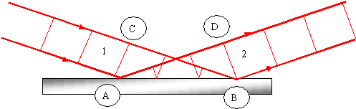

Picture 1.

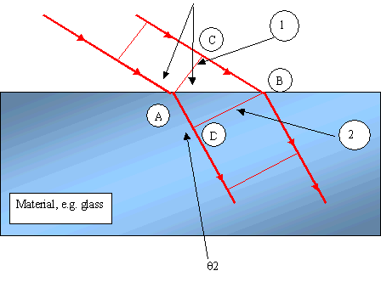

Picture 2.

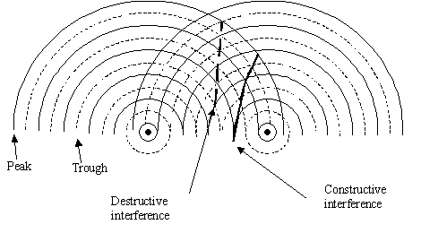

Picture 3.

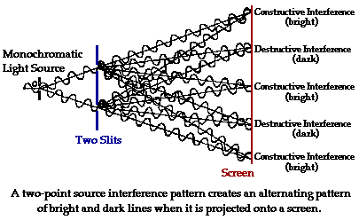

Picture 4.

References

Newton, Isaac. [1704] 1730. Opticks, 4th ed. Book I, Part I, Pr. I; Part 2, Pr. III, VI; Book
III, Qu. 31 (concl.) [public domain]

Physics 2605 Lab Manuel,University of Minnesota School Of Physics and Astronomy,
Minneapolis, MN (2005)

R.Eisberg, R.Resnick, Quantum Physics: of Atoms, Molecules, Solids, Nuclei, and
Particles. (John Wiley & Son’s, 1985). Page 30-33

Tipler A. Paul. Physics, 4th ed. W.H. Freeman and Company, New York. 1999

White, Michael. The Last Sorcerer. Perseus Books, Great Britian. 1997

